8:00 – 9:00 – Welcome – Login – Virtual225Weebly
Read Article – What is Computer Science and What do People do Once They Know it? (handout)
- Introductions –
  - Name
  - School
  - Grade Level
  - What I know about code.
- My requests
  - Solve the cipher on Virtual225. Could you do this or something similar with your students?
  - What codes do you know? Let’s name some. (3 handouts)
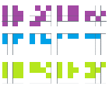
- Decipher the code -

9:00 – 9:30 – Sticks –
- Code – The New Literacy – Video (1:58) Recognize Anybody?
    - What is the Value of learning about code?
    - For what Grade level is it appropriate?
  - What are your challenges? ELD, Time, Assessment, Technology? Support? What do you need?
- Share / Questions?
- 9:30 – 10:15 – Paint to create code. (handout)
10:15 – 10:30 – Break!
10:30 – 10:45 – Context Lesson - Volunteers
10:45 – 11:30 – Hour of Code Introduction - Video (2.01)
- Make an account – Learn Code – that way you can record progress.
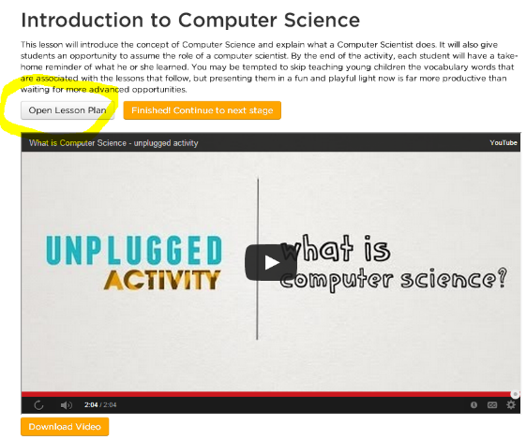
- Unplugged Activity – Video (2.04)
- Open and examine unplugged activity.
- Start Blockly.
11:30 – 12:30 – Lunch! – Please be prompt.
12:30 – 1:00 – Continue on Blockly.
1:00 – 1:30 – Review Unplugged Activities (handouts) (St)
1:30 – 2:00 - Try out other websites. Beyond an Hour of Code
2:00 – 2:45 – Work Time!
2:45 – 3:00 – Questions?
- Fill in online Professional Development Evaluation –
Homework :
- Select an unplugged activity and a plugged activity, or select 2 unplugged activities or 2 plugged activities.
- Prepare.
- Do the 2 activities with your students.
- Write a review of each activity – (1/2 page for each activity)
  - What worked?
  - What would you do differently next time?
  - Describe student response.
  - Relate anecdotal information.
  - Explain your position on requiring computer science in schools. (1/2 page)
  - Sign the petition here if you are so inclined. http://code.org/
  - Email your word document to me @ leslie.lewis@slcschools.org (Total – 1.5 pages Word Doc)
- Deadline for this is October 31, 2014.
Links to your reviews will be available for other teachers to read on the SLEDTECH website.
ROT1 - This is a cipher familiar to many children. Its key is simple: each letter of the alphabet is replaced with the following letter, so A is replaced with B, B is replaced with C, and so on. “ROT1” literally means “rotate 1 letter forward through the alphabet.” The message “I know what you did last summer” would become “J lopx xibu zpv eje mbtu tvnnfs” and so on. This cipher is fun because it is easy to understand and use, but it is equally easy to decipher if they key is used in reverse. This cipher is not suitable for serious use but can be of great amusement for children.
A code is where each word in a message is replaced with a code word or symbol, whereas a cipher is where each letter in a message is replaced with a cipher letter or symbol.

