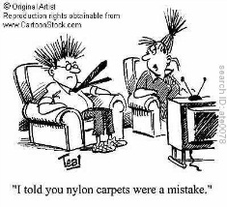
Where? Oh where can my little dog be, oh where oh where has he gone? In the Gallery! That’s where. How many of these can you find in the Gallery? How can you tweak them for your curriculum?
- Dog Bark
- Understanding Magnetism Game – Skool.com
- Stopping By The Woods On A Snowy Evening – Robert Frost
- Red Riding Hood/Goldie Locks - Folders
- Number Line -10 to 10
- Venn Diagram
- Grid paper
- Interactice Numberline Tool
- Dice Image – Make one
- Multiple Choice Question and Answer Page
- Purple Category Sort
- Santa Background
- The Grammar Show
- Link an .mp3 to an object or text.
- Scrolling banner
- Lesson Activity 2 Tool Kit > Techniques – Watch one of the video tutorials.
- Powers
- Hundred Square
- Fraction Maker

