3:30 – 3:45 - Welcome –
- Introductions – Name cards
- Are you signed up for Smart Exchange ?
- Do you have your theme to work on? Keep it in mind while exploring.
3:45 – 4:30 – 5th grade science core
- Vortices – dragging images from Gallery & Internet
- Word Generator
- Object Animations
  - Rotate
  - Shrink and Grow
  - Flip around axis
  - Fade in/Fade out
4:45 – 5:15 – Techniques
- Image Die
- Auto Hide – Move objects from one slide to another, delete slides, clone slides
- Erase/Reveal
  - Tutorial on Erase/Reveal
- Linking sounds
5:15 – 5:45 – Scavenger Hunt II
5:45 – 6:00 – Share 1 thing - Questions?
Next week – Activity Builder, Magic Slider Bar, Recording
Homework – Due January 31, 2013 –
Submit attachments to my email please. Leslie.lewis@slcschools.org
I will be posting these homework activities to the Weebly so that others may use them and you may use those of others.
- Tweak a template from the Gallery or Smart Exchange and make it your own – your grade level, content, colors, etc. We are going to post them. They need to be sufficiently different from the original so as not to violate any copyright.
- Build a 1 page Smart Notebook Lesson from scratch! It needs 5 interactions such as a
  - Video
  - Tab
  - Animated object
  - Color reveal
  - Background
Evaluation Form – LATER GATOR! Please fill this out on the last day of our class. Remind me!
Helpful Pointers-.
- Remember to put away your tool and pick up the Selector tool. This is the hardest thing to remember and often very frustrating when you can’t figure out why you keep getting a text box.
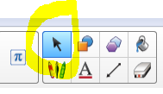
The selector tool looks like your cursor or arrow.

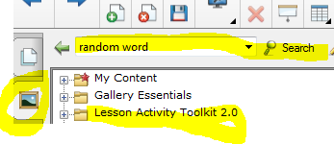
- The Gallery looks like a framed picture.
- Type a topic in the search field after clicking on Gallery to find what you are looking for.
- Lesson Activity Toolkit 2.0 has lots of examples, templates, and pieces of pages like backgrounds and tabs.
- Weebly Address - http://virtual225.weebly.com/sleekersavvysmarter.html

