Recreate the Volcanoes Page using your topic –
This one page lesson contains
  - Standard and/or objective
  - Picture of topic - Volcanoes (For ELL’s and Special Ed. especially)
  - A video of the results of a volcanic eruption (31 seconds – open discussion about time lapse photography, how hot must the truck be and how stupid the guy in the truck is to keep driving it.
  - Correct spelling of a word with an irregular plural (Volcanoes)
  - A flash file of 10 pages that explains in pictures and words how a volcano works. (~<5 - 10 minutes)
  - Discussion about how Earth’s surface can be changed slowly and/or rapidly.
  - A curriculum-based, on-the-fly assessment that tests information from the movie and flash file.
Border - Gallery - Search – Borders – Choose Pictures – Drag one over
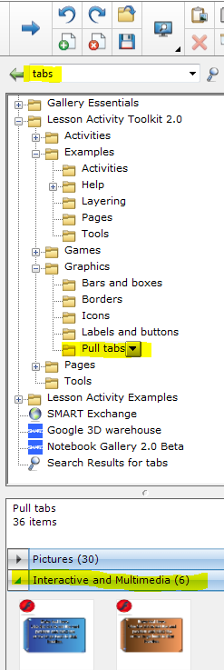
Tabs -
- Search – Tabs – Choose Interactive & Multimedia – Drag one over
- Click on the arrows on the top left of the tab. The Push Pin and the single arrow work together to return the tab to its original location when you are done reading it and want it to return to its original position. (These arrows appear on all objects that can be edited.)
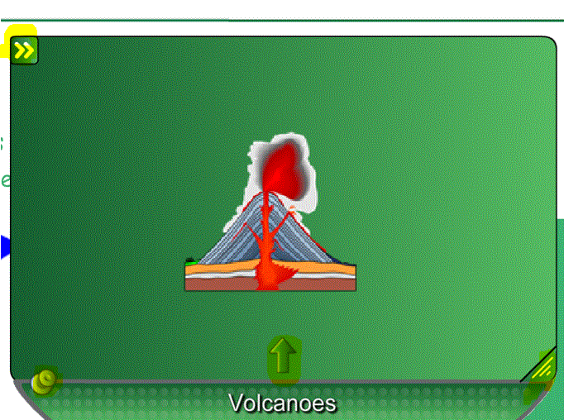
- Choose text on one of the tabs and image on the other. You will put the Standard or Objective on one of the tabs.
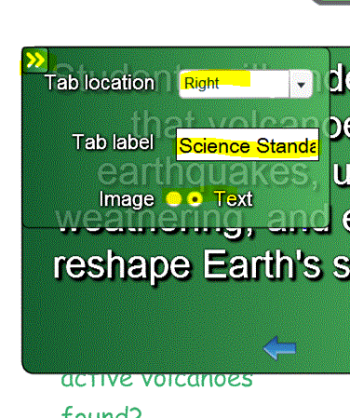
- Here is where you will choose the tab location, the tab label and either text or image.
- To link a web page-
  - You don’t want to copy a web page address and then have that big, ugly address appear on your page.
http://www.uen.org/core/core.do?courseNum=3050
  - Instead, give your URL something to link to, an object or descriptive text. (in this case the word Volcanoes & the picture of the Volcano mid-page)
  - Right click on the object or text, or chose the down arrow on the object or text, select Link.
  - In your browser, find the page to which you want to link, highlight and copy the URL. Minimize the browser. (The browser is Internet Explorer, Chrome, Firefox, etc.)
  - Go back to your Smart Notebook File. Paste the address in the cell marked Address. Use right click copy paste or Ctrl V. Chose corner icon or object. If you choose corner icon, a little globe will show up on the left bottom of your text or image. You will have to click there to open the web page.
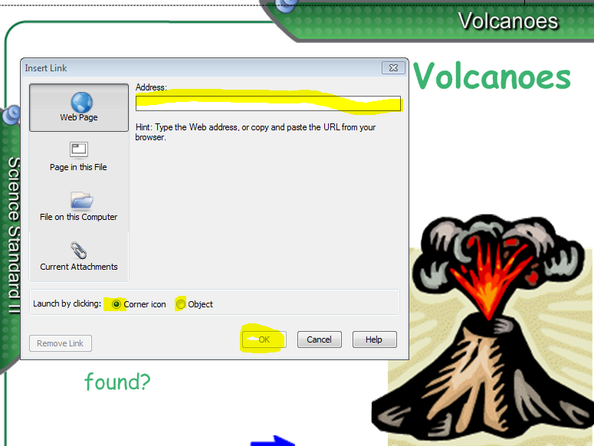
If you choose Object, you will just click anywhere on the text or the graphic to open the web page. Both choices have advantages and disadvantages. The globe helps me remember there is something there to click but it also gives away the surprise. After you have linked an object or text it becomes harder to work with because it opens the web page every time you click whether you want it open or not.
- Animating Objects – Science Benchmark
  - Chose a shape
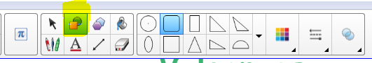
  - Right Click on the shape or click on the down arrow at the top right – A window will pop up – Chose Properties (very bottom of window) -chose Line Style to change the color of the border and Fill Effects to fill the shape.
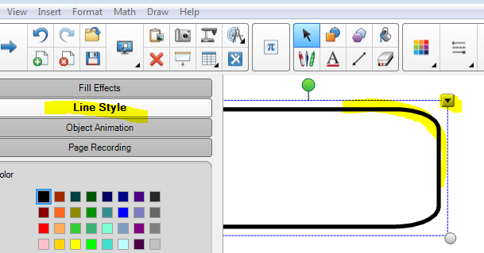
  - Select your text tool – type your text within the borders of your object. You may need to Group the text and the object. Use the Selector tool (arrow) to draw a box around both the text and the object. Right click or down arrow, Select Grouping – Select Group.
  - Object Animation. Right Click or Down Arrow – Properties – Chose Object Animation – Select the Type of animation you wish as well as any other pertinent properties.
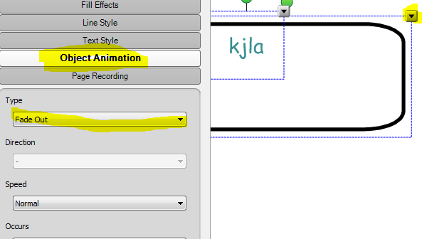
  - Test the animation.
Hide Text With Color – on a separate sheet.

